附件2.团支部风采展示推送参考链接

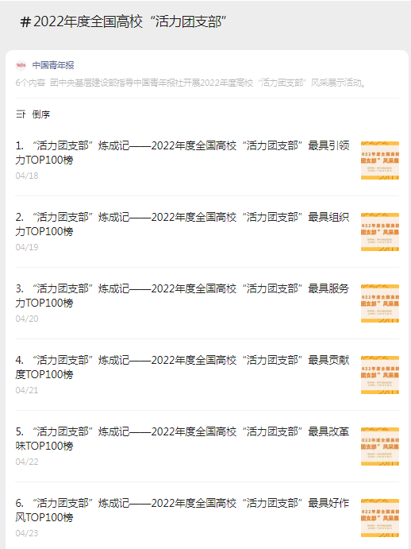

链接：

https://mp.weixin.qq.com/mp/appmsgalbum?__biz=MjM5NjY3NjEyMA==&action=getalbum&album_id=2889054806299164672&subscene=&scenenote=https%3A%2F%2Fmp.weixin.qq.com%2Fs%3Fsearch_click_id%3D11205536617838168603-1702876105855-4937585271%26__biz%3DMjM5NjY3NjEyMA%3D%3D%26mid%3D2653383312%26idx%3D2%26sn%3D971457f339443a984e517bba24f929c2%26chksm%3Dbd365de78a41d4f197f428573bcb56b689f60ab8af751f358615d626c1bce60e50d23165cec9%26clicktime%3D1702876105%26enterid%3D1702876105%26subscene%3D0%26ascene%3D65%26devicetype%3DiOS17.1.2%26version%3D18002c2d%26nettype%3DWIFI%26abtest_cookie%3DAAACAA%253D%253D%26lang%3Dzh_CN%26countrycode%3DCN%26fontScale%3D100%26exportkey%3Dn_ChQIAhIQrAg%252FxKRUGbYhW%252BgW%252FfQkmhLaAQIE97dBBAEAAAAAAC0vLdNGwUsAAAAOpnltbLcz9gKNyK89dVj0K%252FVH1YYFVFx5gOWeyYE66fJngPOgYaSTJzqq4BehPM6GZ4yf8FvXyZbyvz1kS98cBiSE6DindCxjDz8Lbhfqh1O5Gmh5476Z1PLpOxYVHOM9bz%252Fkz5xmMSs%252FdIFAtinrvWVk5rQWPc9%252FsKwbL1sG4sQy411KA3Vih6%252BMemQgSC3Rtb4shxxcLGjWpKPAxnQDsLsoSz7IrsJ%252BPiC8QwLzViOc8dFcYzE0AmtninEjoFbpAI9s%26pass_ticket%3Di7HMaWzunSXFAWgo5LfmhWefCpq1pWKOkTip%252BgvBxKtC9aWcpnyGF%252FXemJ2jLDLbSwuTkBsdEsovNR%252FL2GMrZA%253D%253D%26wx_header%3D3&nolastread=1#wechat_redirect